**Final Internship/ Co-op report**

My name is Randy Akuffo and a Final year student at Kennesaw state university. This semester I was part of a successful co-op/ internship Landis+Gyr has is an industry leader in energy management solutions. with an advanced metering infrastructure and other cutting-edge smart grid technologies, they help utility companies all over the globe improve their operations, protect their assets, lower their operating costs and provide better customer service. With a focus on quality, reliability, and innovation Landis+Gyr’s portfolio of products and services still remains the industries top manufacturer. Landis+Gyr has a wide range of products and services they provide for their customers. some of these products include:

* Gridstream Load controls
* Smart Electrical Meters
* Commercial and Industrial meters
* Gridstream Advanced communication solution

The company is widely spread in the united stated with many customers which includes some of the largest utilities in the industries. Some of these utilities include. Austin Energy, Tucson Electric, Middle Tennessee electric etc. fortunate for me I was able to work with most of these large utilities as a support assistance with help from my supervisors.

The Co-op internship program offered by Landis+Gyr is a 3-term rotating program where students enrolled in the program must work for 3 rotating terms taking a one term break in between. The co-op is intended to teach students about the corporate structure and introduce them to the corporate life for when they graduate. As an Engineering co-op/intern. I was responsible for various task and responsibilities on a daily basis working with firmware upgrades and database querying. As an engineering co-op, I was also responsible for costumer facing issues like getting devices that are not in normal state to go normal and managing CRM cases for customers and my team. During this internship period I have been exposed to different types of technology some related to my major and others not. I have also had experience and increase my sql skills which will help me in my career as an IT professional I have written complex queries that is used by my team and some projects that I’ve worked on. below are screenshots of some of the queries and processes that I’ve been privileged to be part of.

Screenshot 1.1 (Mapping of problem meters for troubleshooting using Cold Fusion and Google APIs)

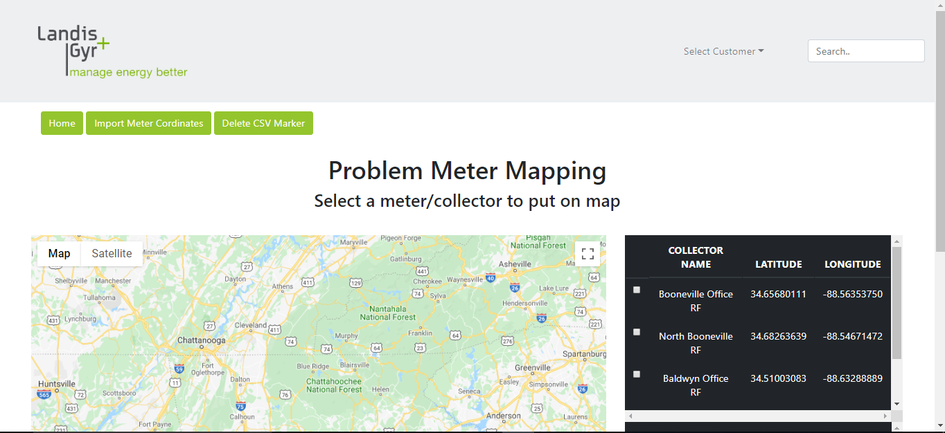

Screenshot 1.2 (Queries/code used in the above webapp Cold fusion)

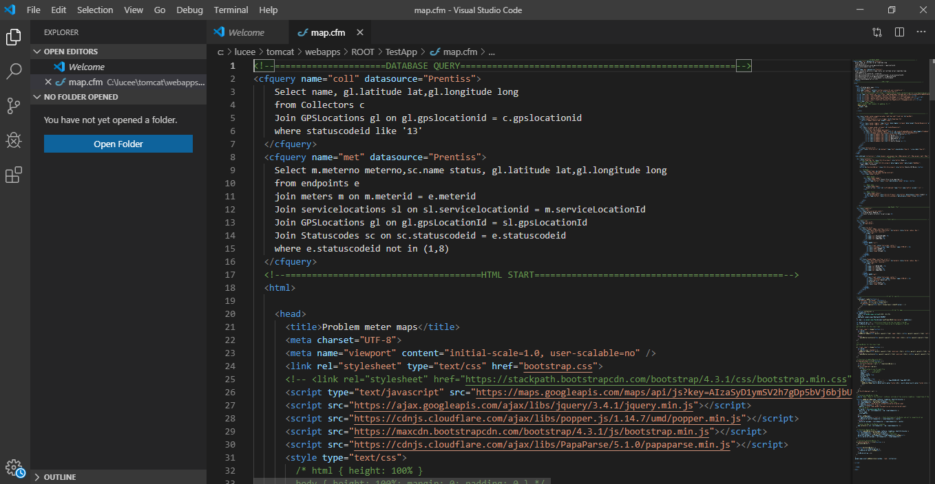

some of the things I was privileged to do and learn from this internship are, I was able to study the company’s proprietary software and how it works. I did learn and improve on my communications skills as well as my team building skills. had the opportunity to work with a great team from whom I learnt a lot from. I cannot think of any think that can fit into a negative category. Landis+Gyr is a well-organized company with departments for every solution. All departments worked efficiently to avoid any situation with the co-op/ internship program.

The Internship has shaped me professionally to be able to enter company well ready. I have been able to shape my team and time management has improved well for me to be able to be successful to in any professional environment. in addition to all the professional achievements, the internship program at Landis+Gyr offered interns with team building activities. Starting this internship, I wish I had known the basics of energy and the power industry. Even though it was very easy to blend in and learn very fast. Somethings would have been much easier to grasp on and excel in with the basics on energy and power.

Through out my time at Kennesaw State University, I have taken numerous courses with some IT related and other being general courses. Some of the courses that I took to prepare me very well for this internship regardless of the background or discipline where.

* Introduction to databases
* Information security fundamentals
* Operating systems fundamentals
* Database Systems
* Introduction to networking
* Professional Practices and Ethics
* Introduction to Web Development

Most of these courses did prepare me for the internship as well as most of them has gotten me ready for whatever career path that I choose to take. Introduction to databases and database systems is one of the courses that has been very helpful during this co-op period. Everything I learned from writing simple queries to optimizing relational databases is something I have used though out this internship. During this course, I learnt how to use Oracle developer as a DBMS which gave me a lot of exposure in oracle databases. From the beginning of the co-op I have used oracle as my database engine and have learnt a lot from it. I have written simple and complex queries to pull large data for company use and to help solve issues. So, I am pleased to say some of the best courses I’ve taken so far are ones related to databases. I am currently taking user centered design which is geared toward interface design. This ongoing course gave me inspiration in designing screenshot 1.1 as my internship project for Landis + Gyr. The user interface part of the project was written in HTML and Bootstrap. Although we did not study that in class as part of the course. I learnt how to use user centered design to implement this project. The flow of the application from page to page was influenced by it. Introduction to web development was also helpful during this intern/co-op project.

I was taught professionalism during the Professional Practices and Ethics class. This course really opened my mind about how to be professional at work and in any professional environment. During my internship, I came across some of the test cases I learnt in this class and the ethics I studied help me to get through some of the issues. And this is not just relating to the internship but it’s something that will be with me through every professional environment I find myself.

In conclusion, I am very pleased to have been part of this internship program both for KSU and Landis+Gyr. I have learnt so much to take me to a lot of places and to prepare me professionally for any career path I find myself. I will be encouraged anyone who seeks to be part of a professional world after school to embark on this journey. Not just as a professional exposure, but it also helps you to learn a lot of soft skills that you will require everywhere you go. I am pleased to say this was a successful internship program and I am glad to be part of it.